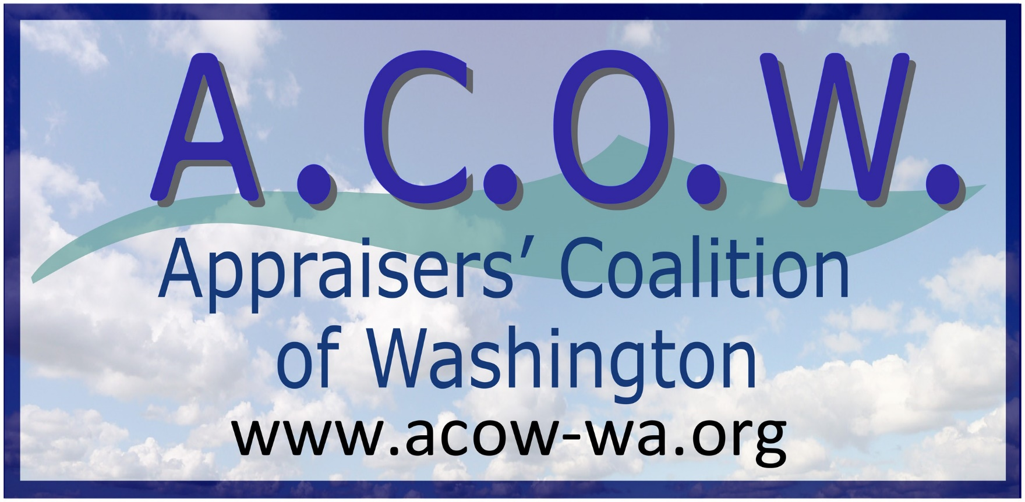
P.O. Box 2299
Port Orchard, WA 98366
(206) 622-8425-ACOW-Office
info@acow-wa.org

11/17/2018

NOTICE OF ELECTIONS - 2019 Appraisers’ Coalition of Washington Board of Directors

To All Appraisers’ Coalition of Washington Members

On Tuesday, November 13th the following nominations were made for the 2019 ACOW Board of Directors:

President Robert “Bob” Mossuto Jr. Western Washington
Vice President George Nervik Western Washington
Secretary Mike Rock Western Washington Previous Board Member/New to Position
Treasurer Bob Meeks Western Washington Previous Board Member/New to Position
Director (OM) Kirk Dosser Central/Eastern Washington
Director (OM) Mike Fredrickson Central/Eastern Washington
Director (OM) Penny Crowe Western Washington
Director (OM) Tom Weaver Western Washington
Director (OM) Philip Gray Southwest Washington
Director (IM) Randy Berg Eastern Washington Newer ACOW Member/New to Position

The 2019 Elections will occur during ACOW’s annual general membership meeting on Tuesday, December 11th at 5:30 PM. If you are a member of ACOW and you would like to cast a vote, you must attend this meeting. The meeting will be held telephonically. The number is 515-739-1033. When prompted, enter 872158#. Once your attendance has been acknowledged, please place your phone on mute and wait for further instructions.

Following this meeting, there will be a board meeting of the newly elected board members. Outgoing members are encouraged to stay for this meeting to discuss the transition of positons. As always, all members and nonmembers are welcome to attend.

Best Regard,
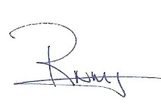
Robert "Bob" Mossuto
President
Appraisers Coalition of Washington
(206) 280-0335-Cell
Bob@bnappraisalsinc.com

Notes: OM – Organization Member
IM – Individual Member

