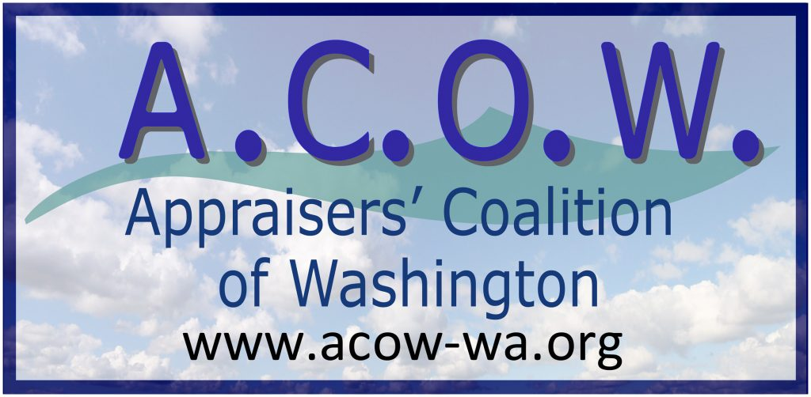

Check Payment Form
Your contribution to ACOW is considered a lobbying expense and is non-deductible.
Select one:
New Member $75.00 per year
Renewal $75.00 per year
Donation $
Name:
Address:
Email:
Phone:
Company:
Appraisal Organization or
Chapter Affiliation:

Please make checks out to ACOW and send with this form to:

Appraisers’ Coalition of Washington
700 Sleater-Kinney Rd SE Suite B-345
Olympia, WA 98503
Email: info@acow-wa.org

